Trial#1: OSPF with 4 routers

1. Create a slice on GENI. Add resources and choose *OSPF 4-node(IntaGeni)* from Choose Rspec🡪select existing. Choose the aggregate accordingly. Reserve resources and wait them to be ready.
2. Login into server and client.
3. Ping server from client using command ping 192.168.20.10.
4. Get the traceroute from client to sever (with all routers working appropriately) using command traceroute 192.168.20.10.

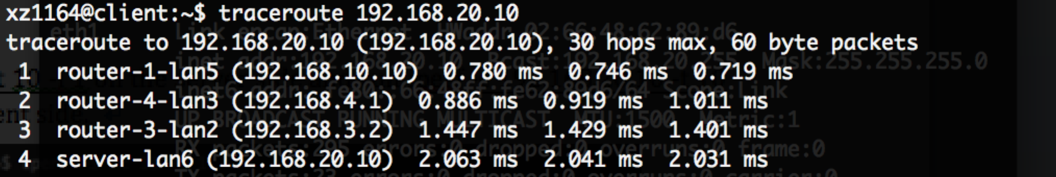

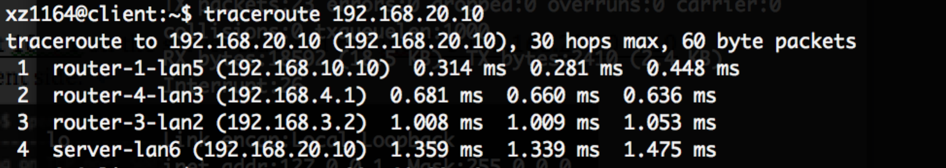

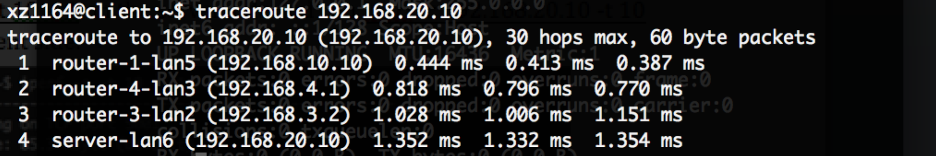

1. Iperf test

Run iperf -s -t 10 -i 1 on the server side and run iperf -c 192.168.20.10 -t 10 -i 1 on the client side.

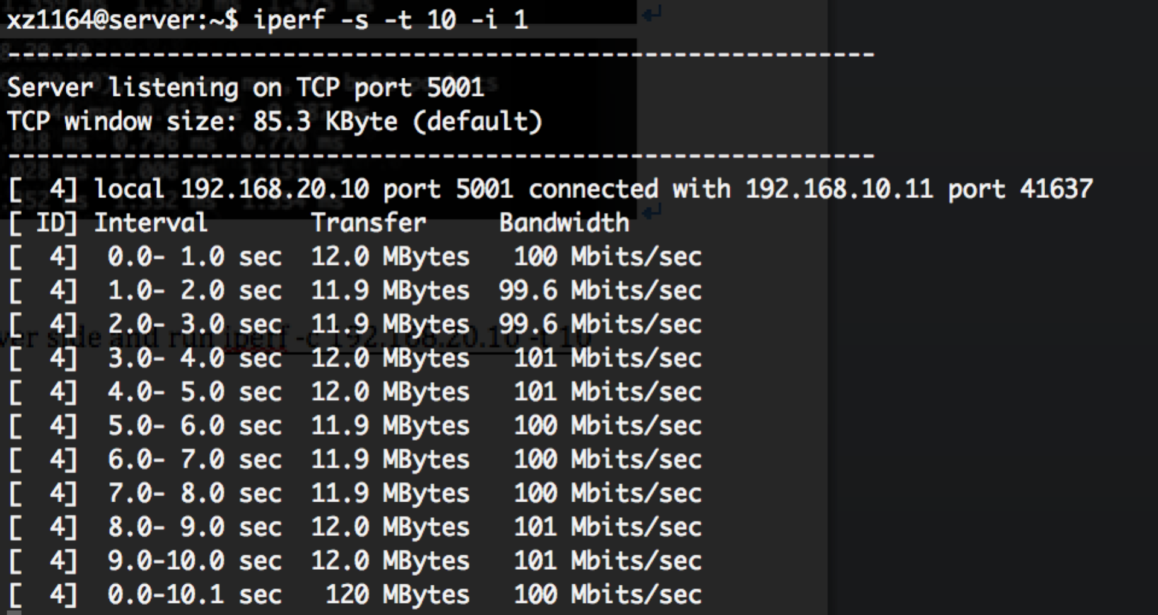

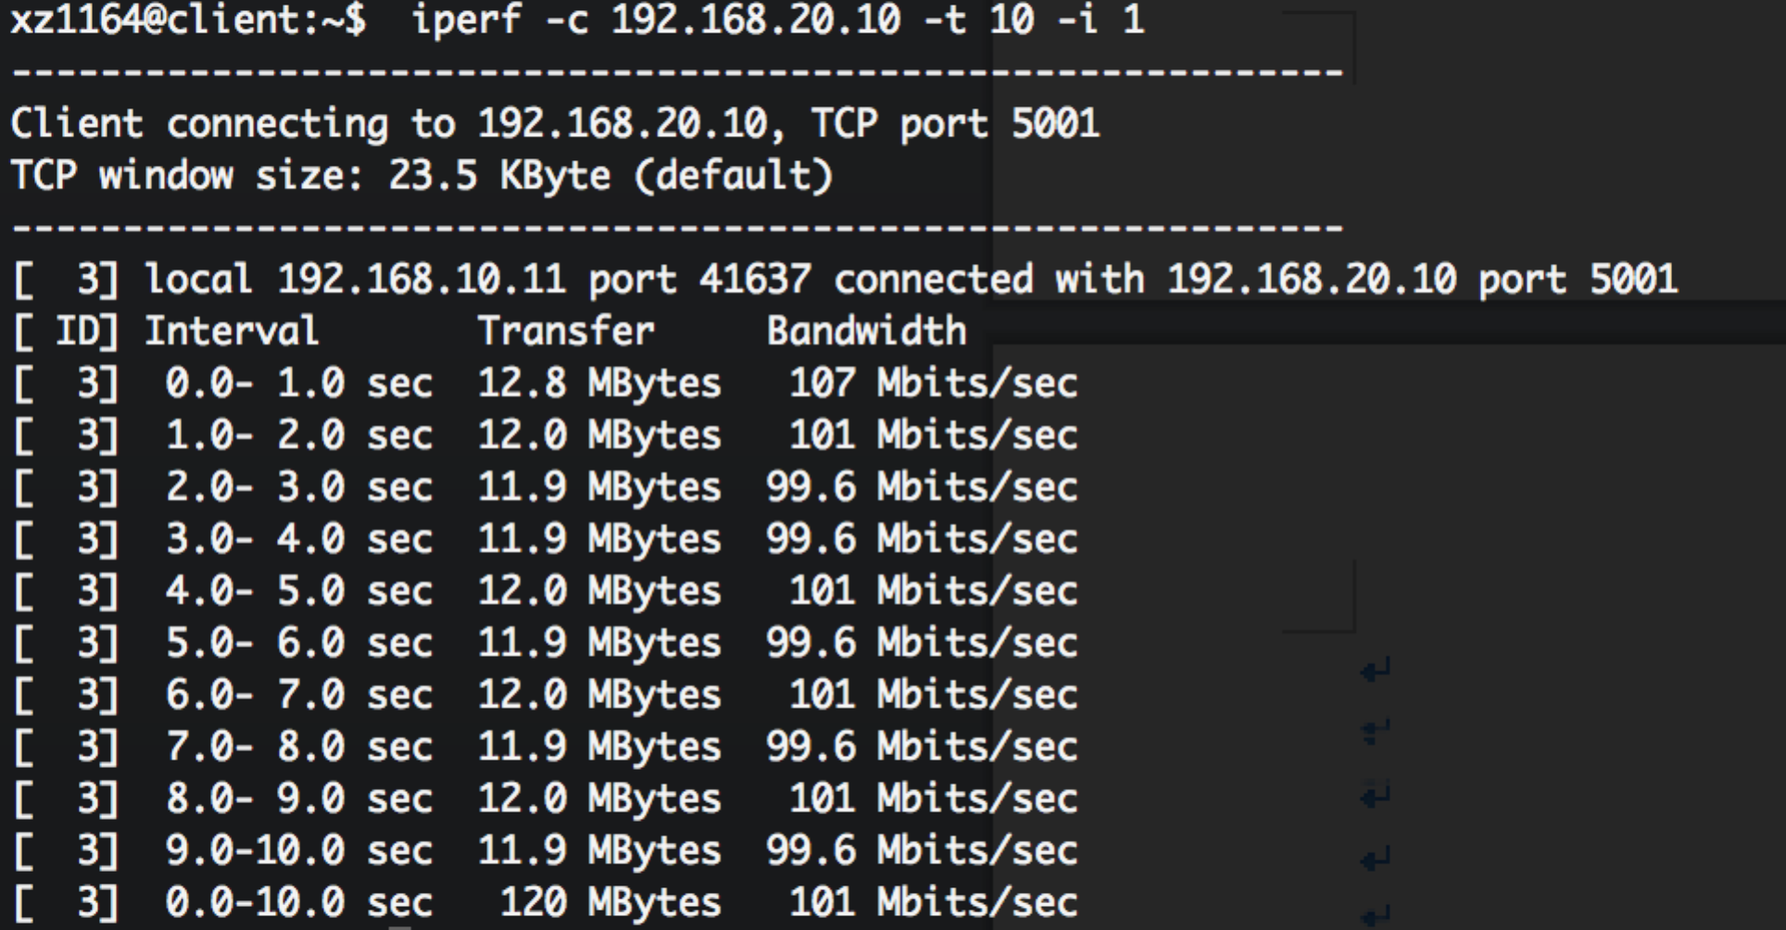

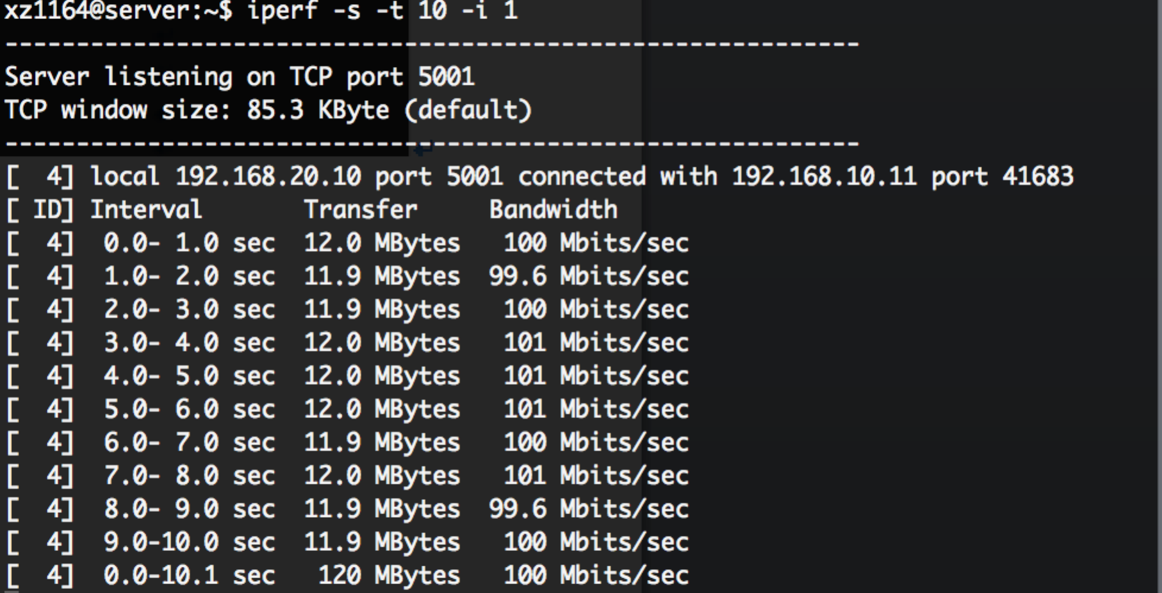

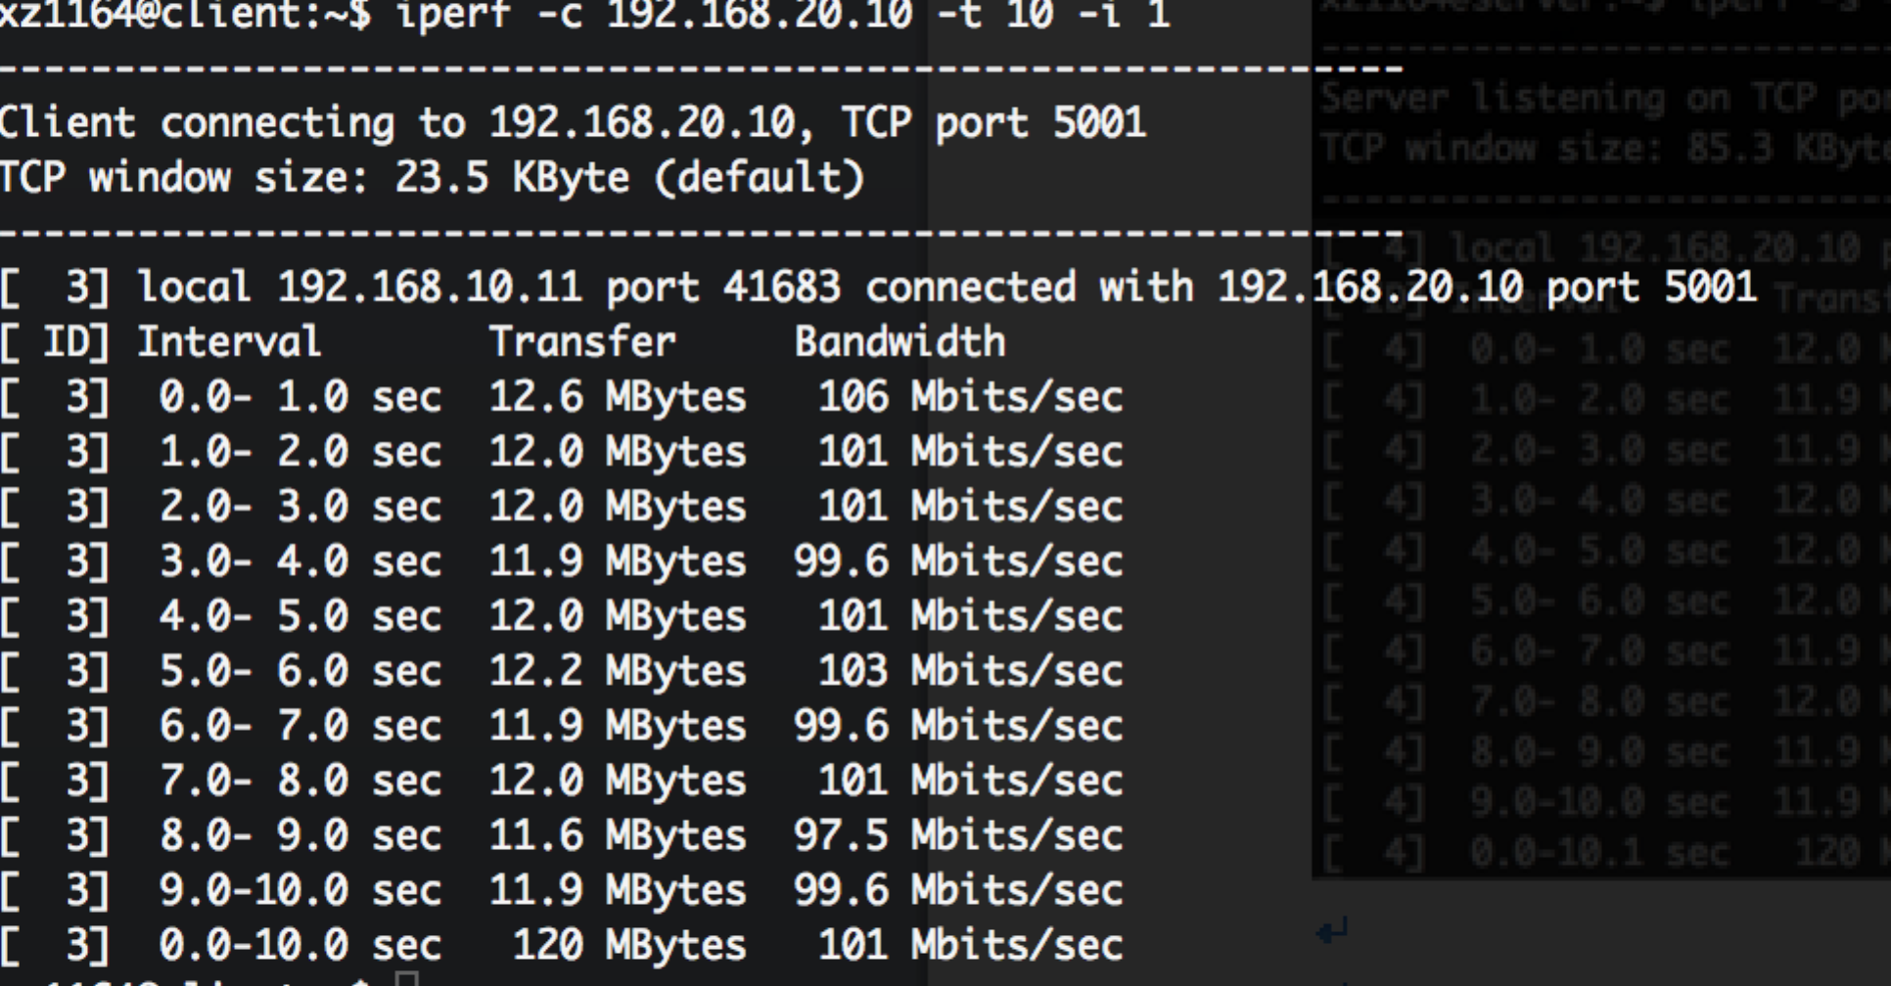

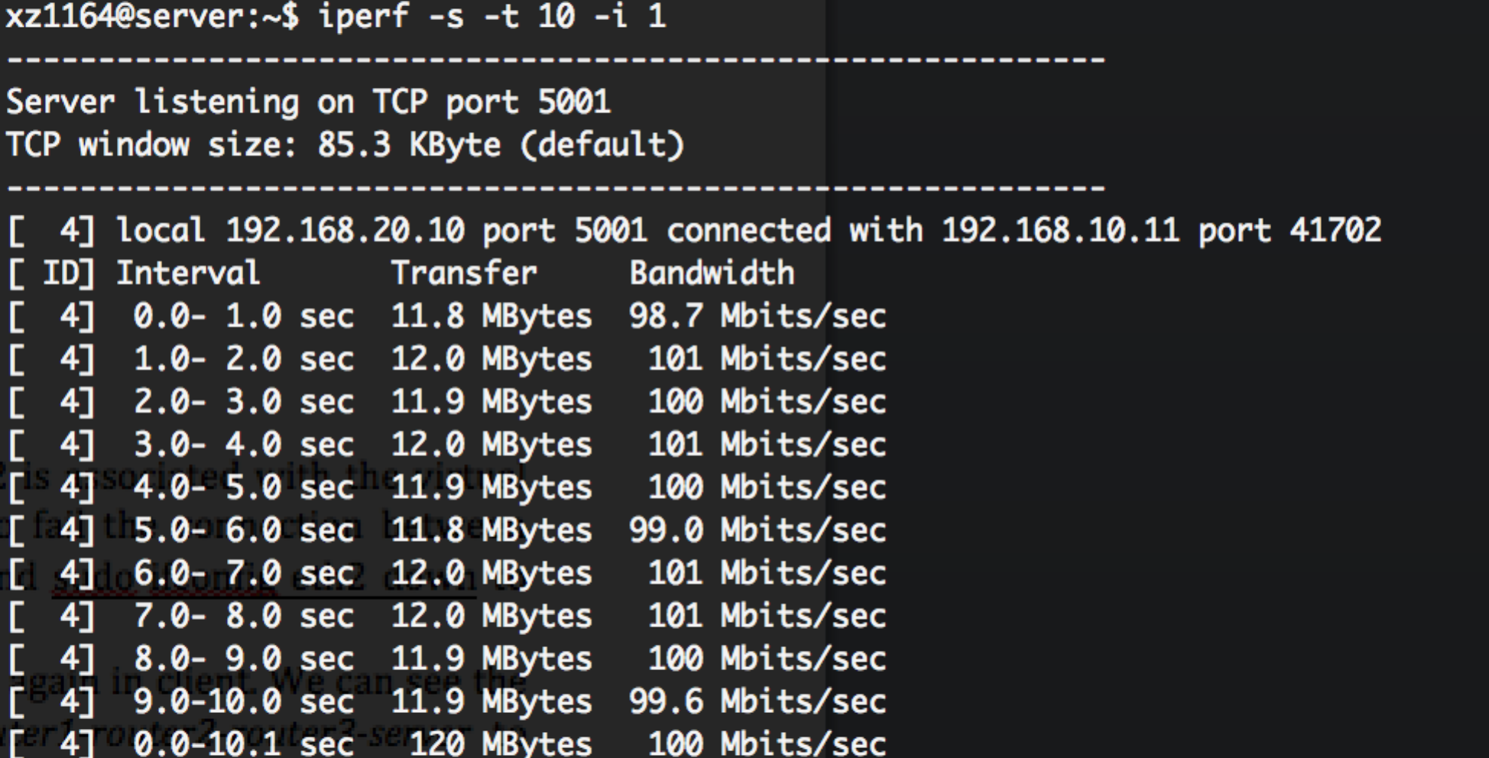

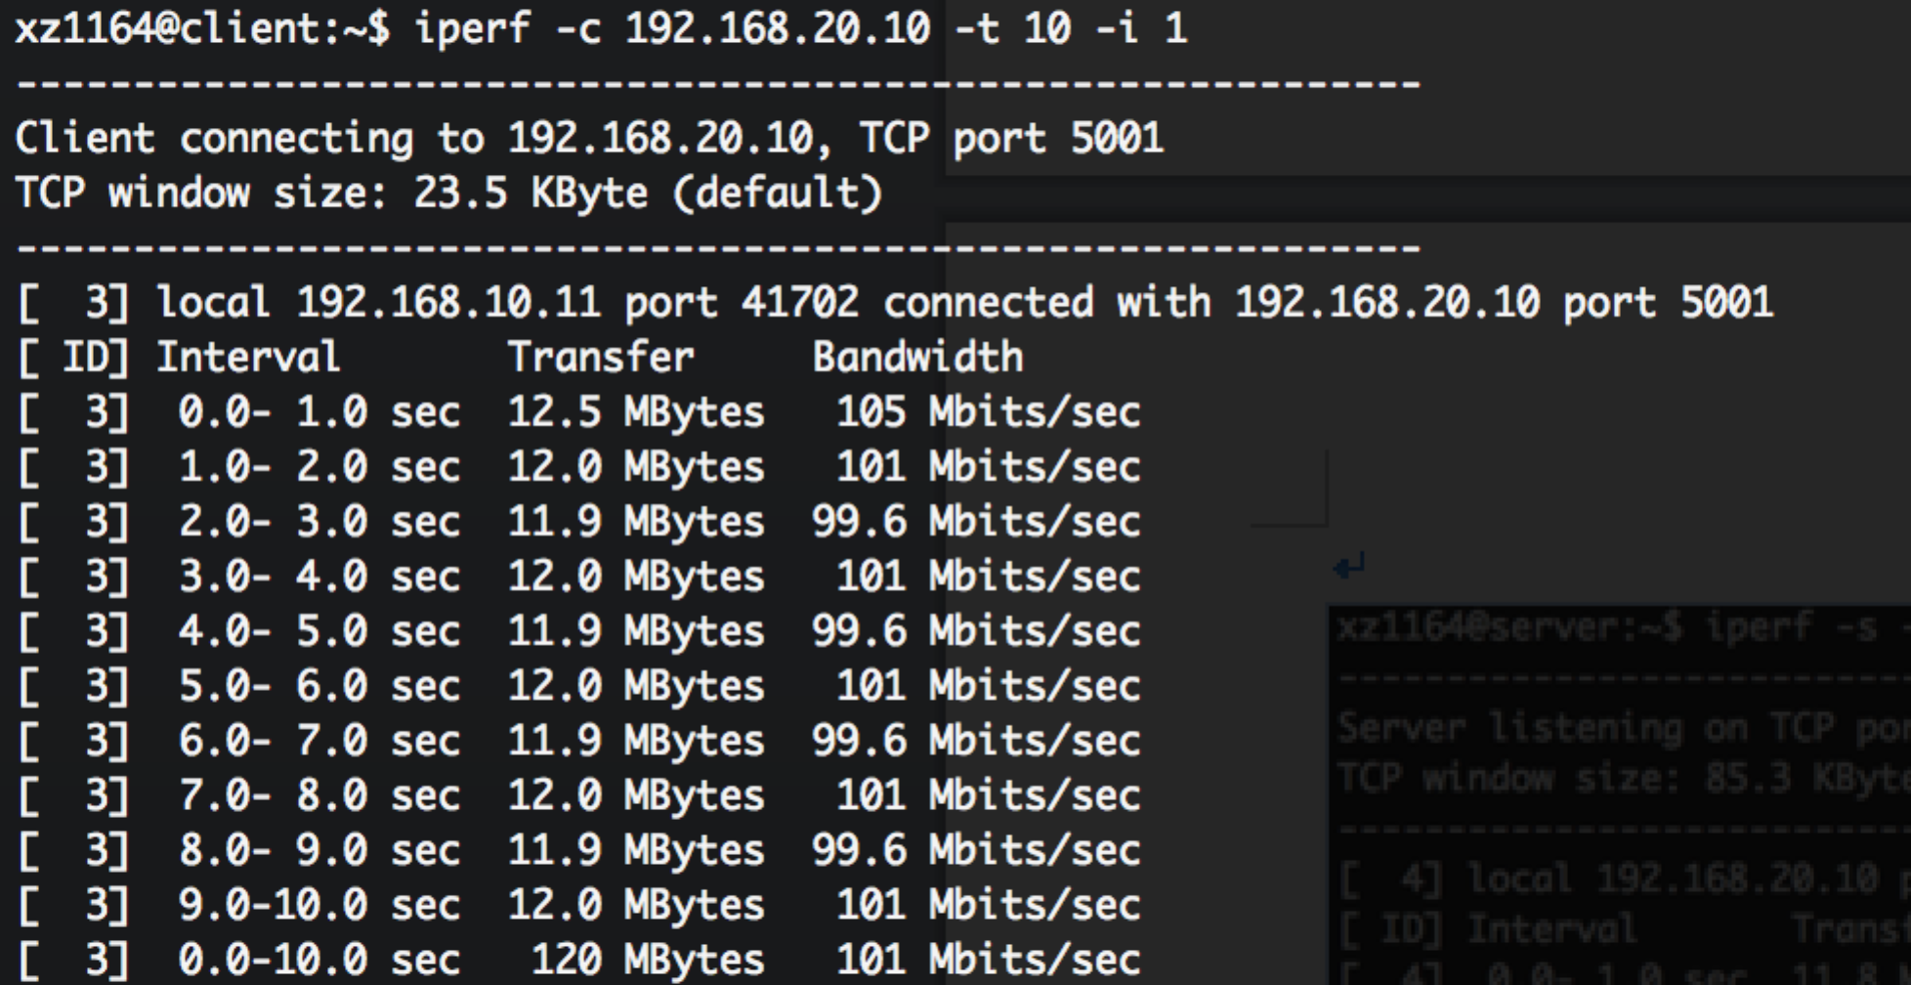

ii)UDP

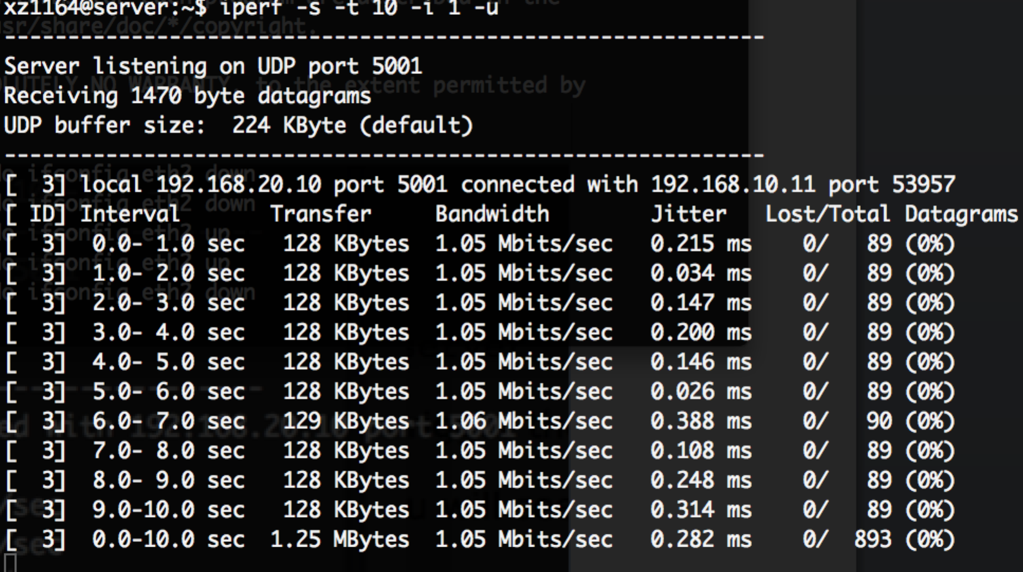

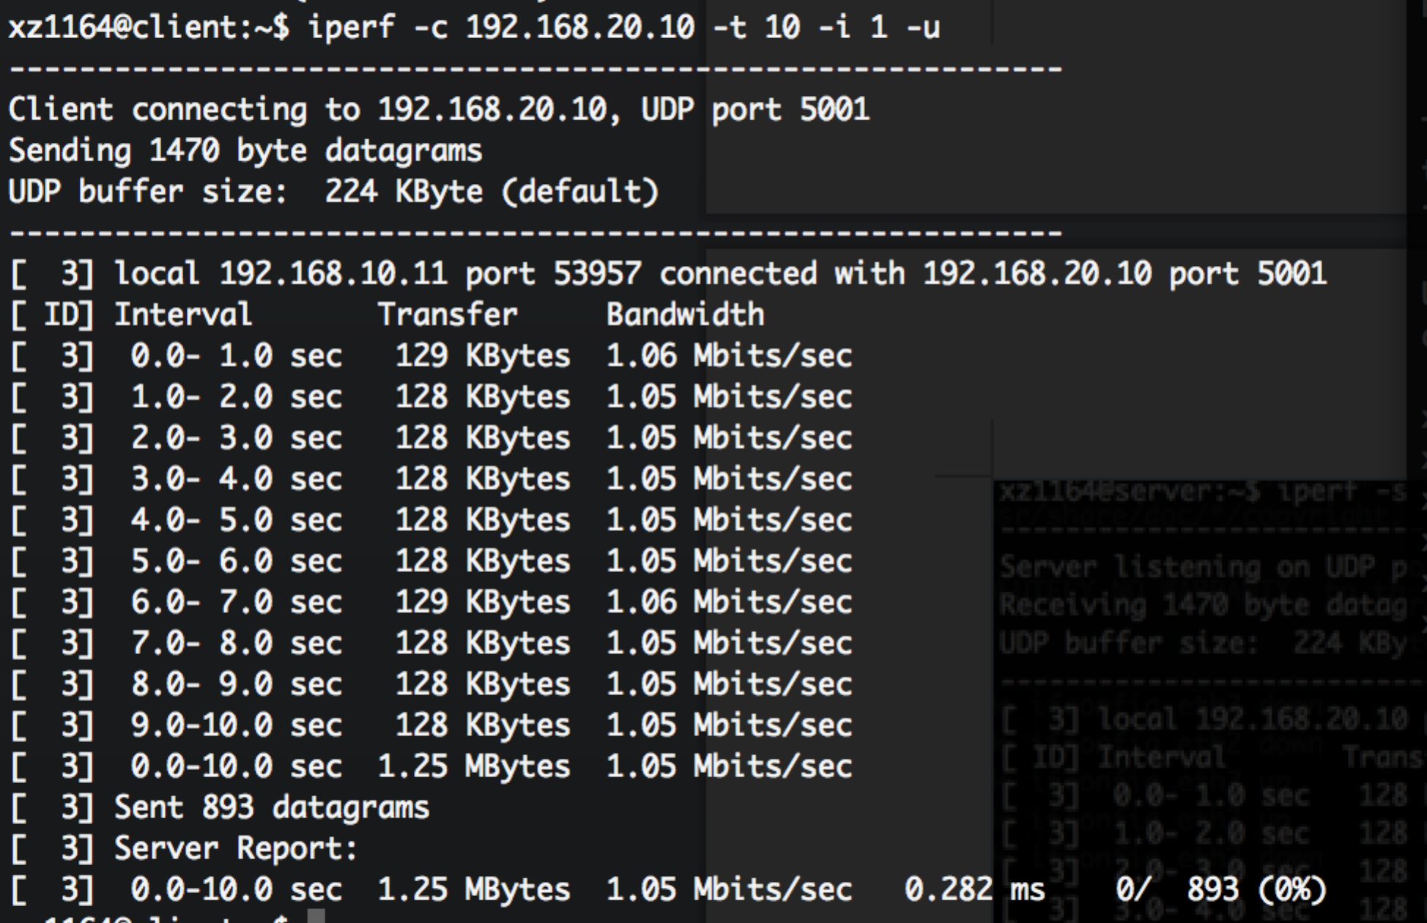

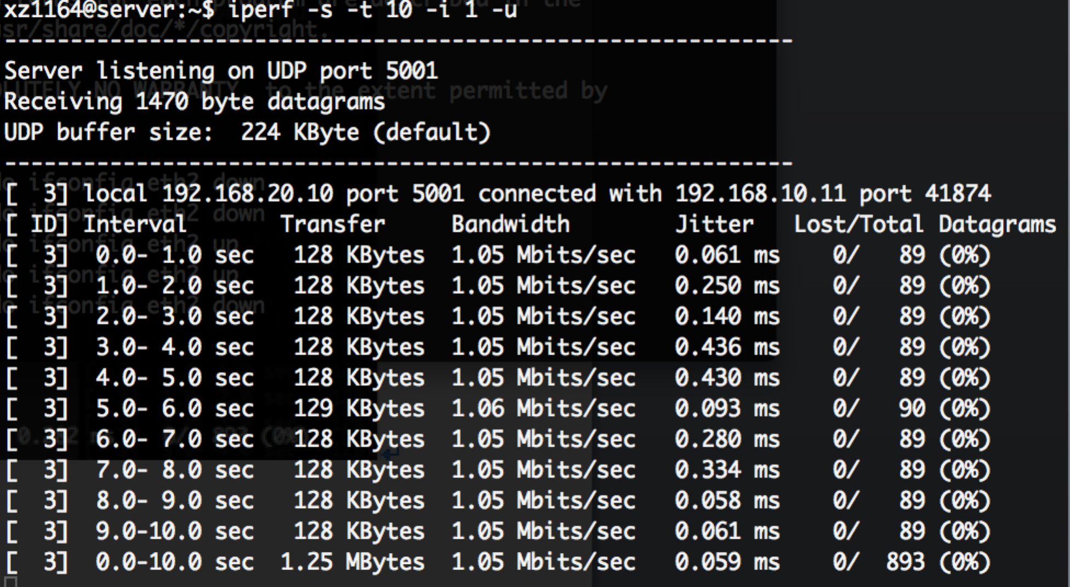

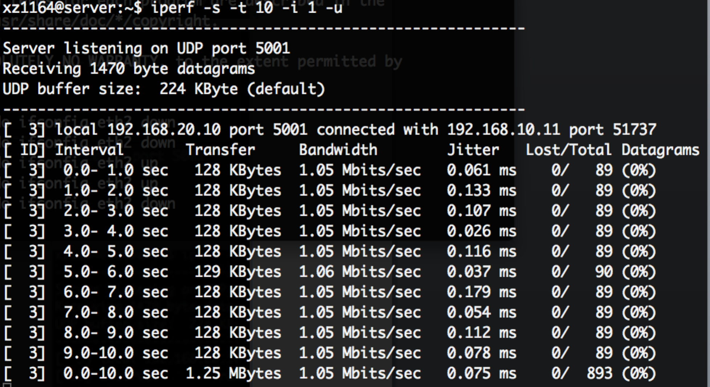

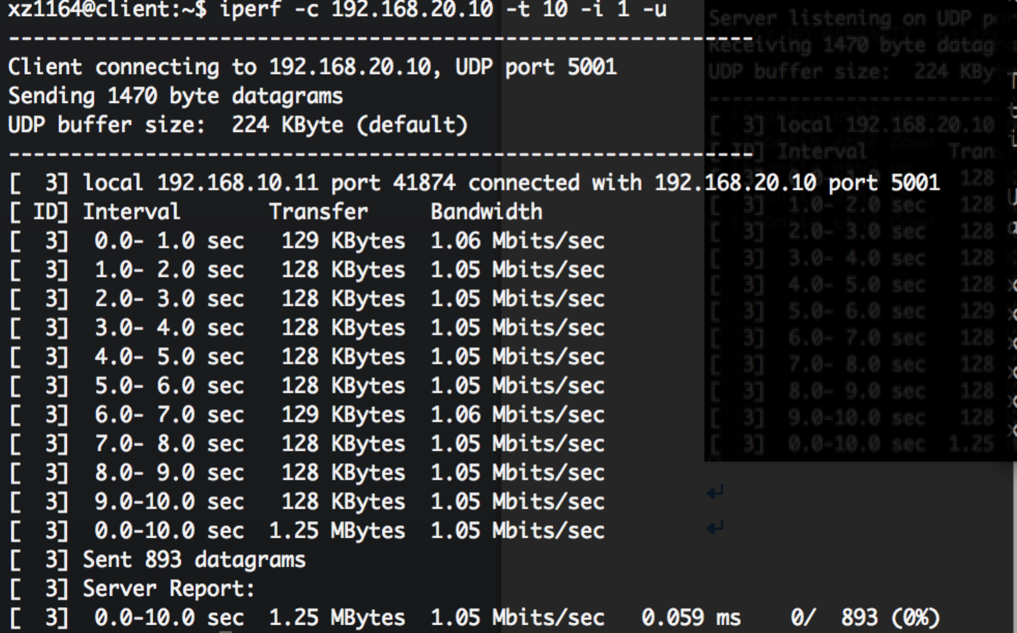

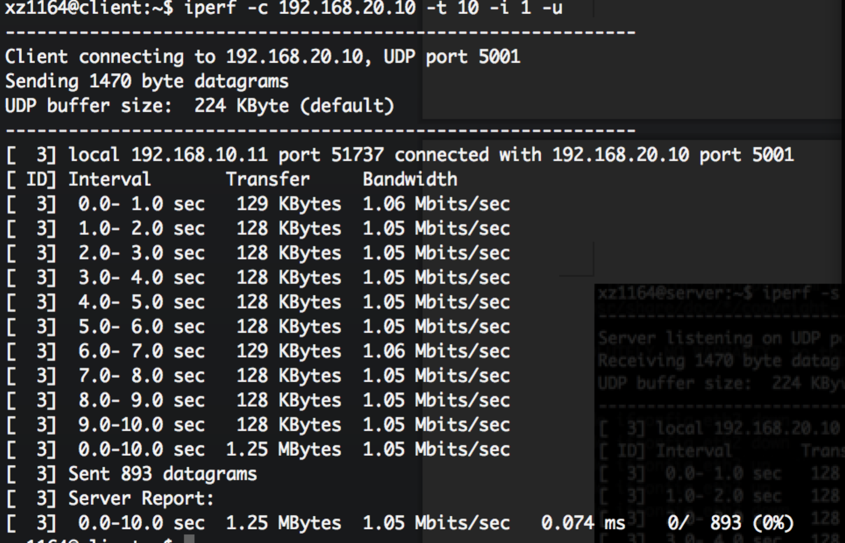

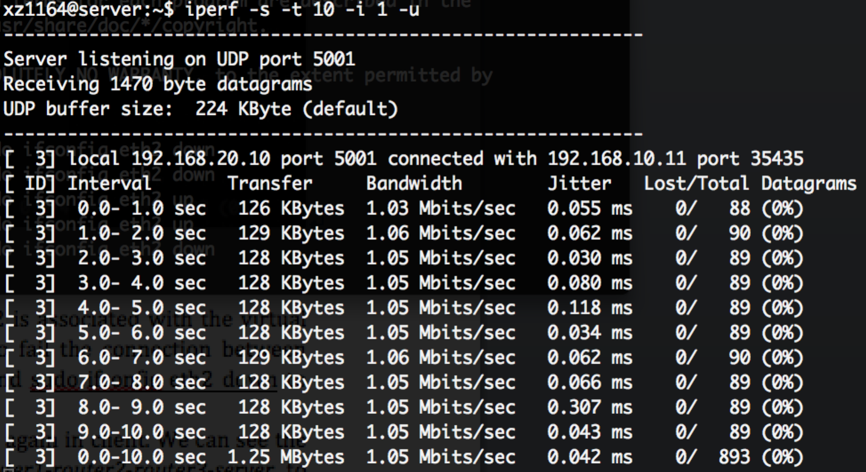

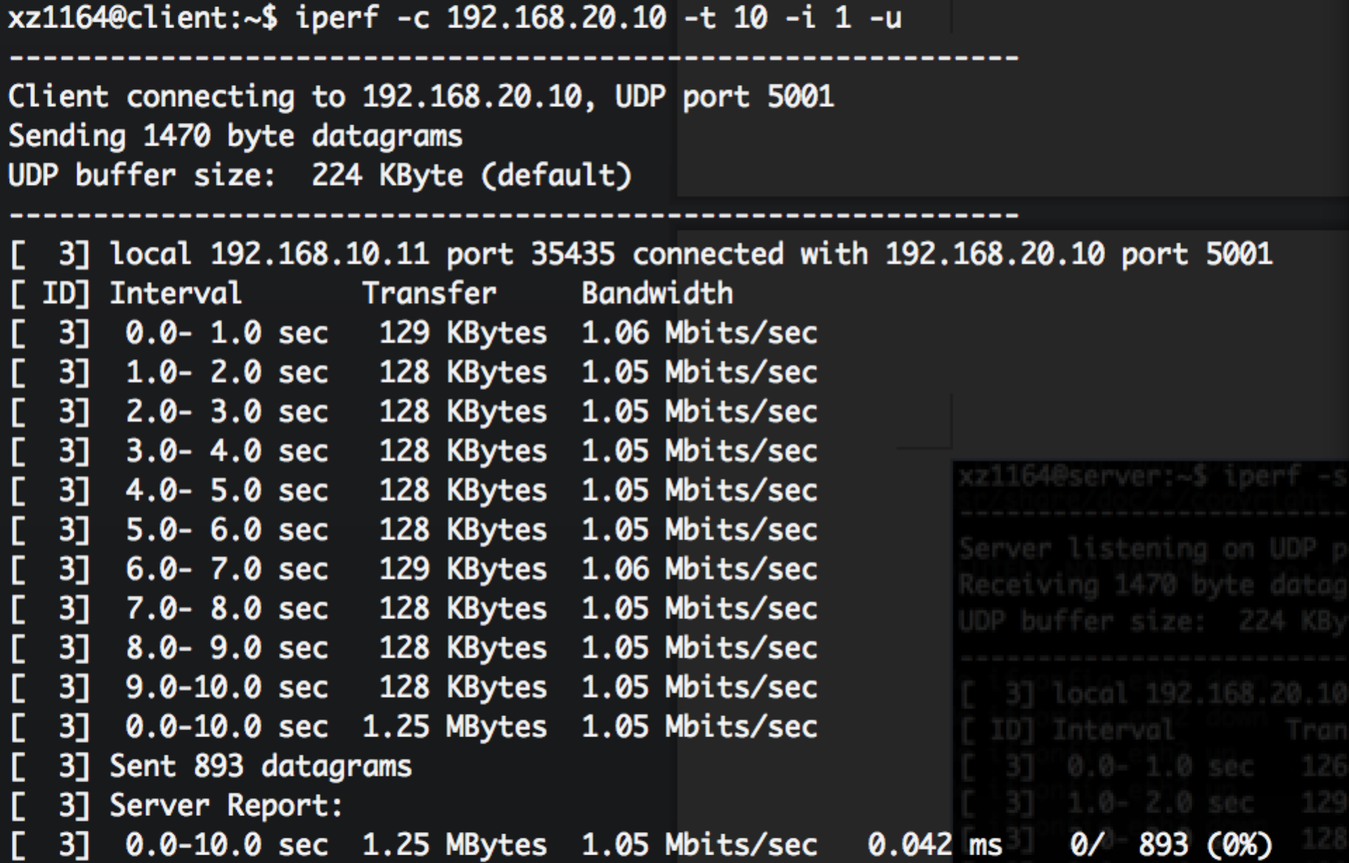

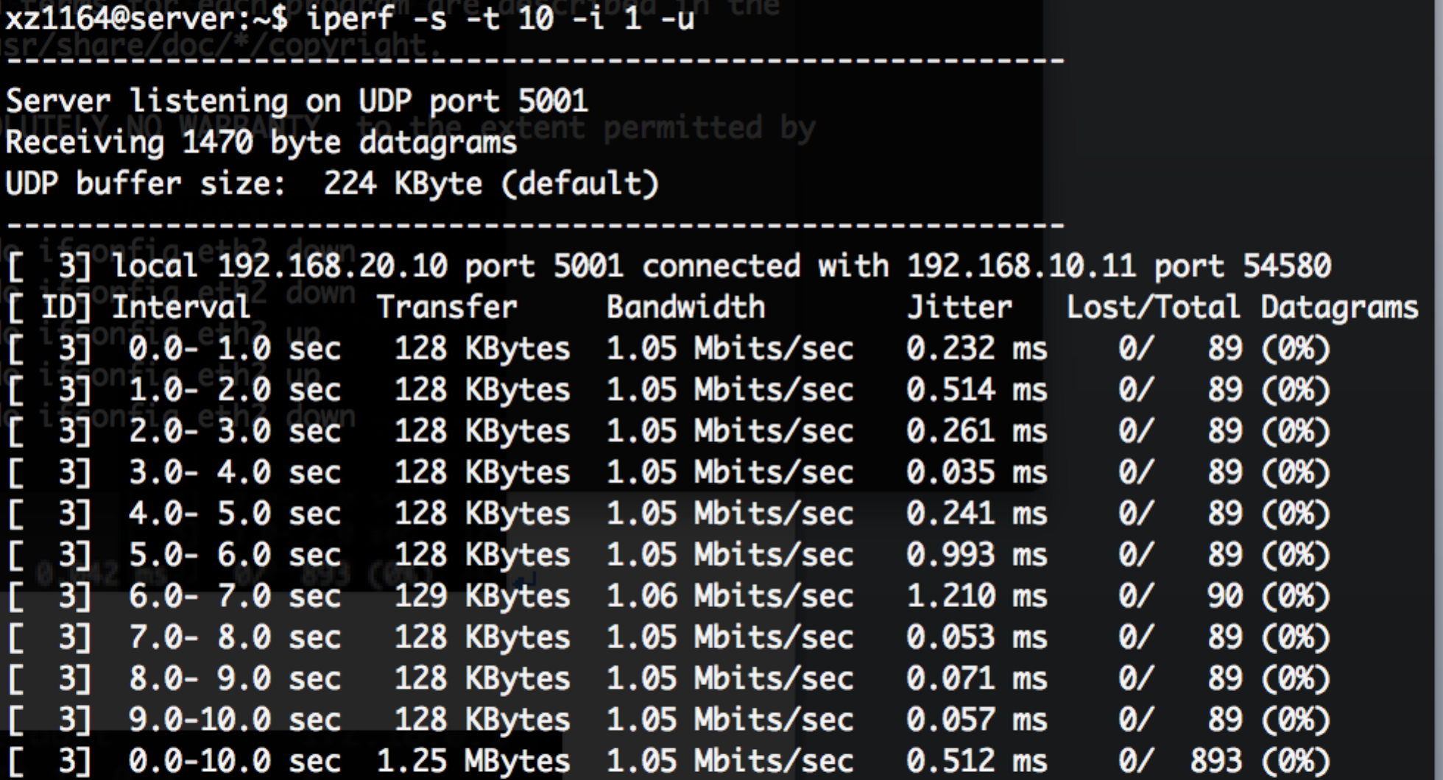

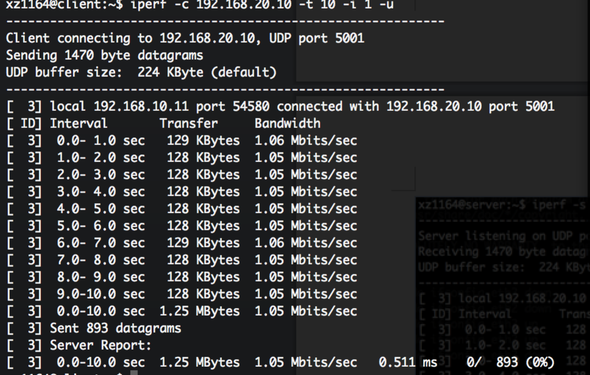

1. Routing table

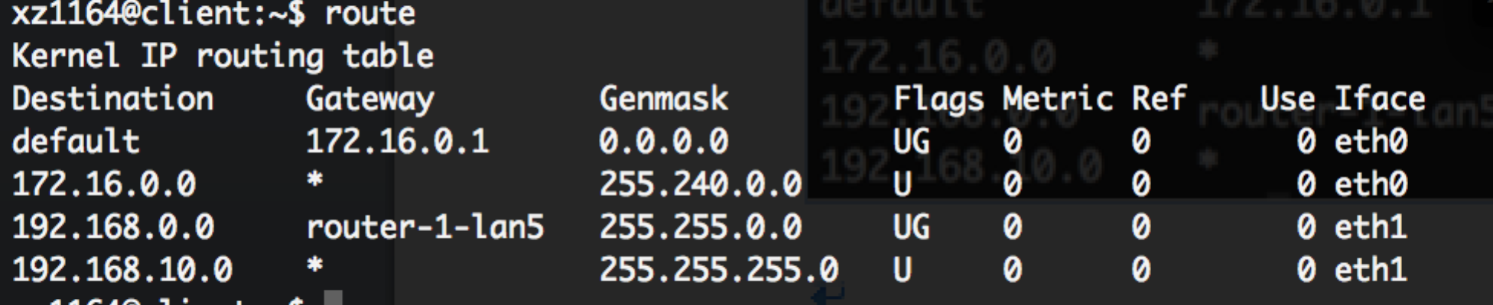

1. Login into the router2.
2. Using ifconfig in router2, we can find router2 is associated with the virtual link (192.168.1.0/24) to router1. In order to fail the connection between router2 and router1, we can use the command sudo ifconfig eth2 down to bring down the interface to router1.
3. At this time, we run traceroute 192.168.20.10 again in client. We can see the traceroute to server change from *client-router1-router2-router3-server* to *client-router1-router3-router4-server.*

